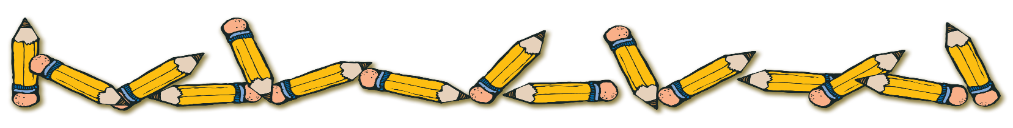
WELCOME
To 2nd Grade
Mrs. Mandos
SUPPLY LIST

- 2 large glue sticks
- 1 sturdy pencil case
- 4 hard heavy-duty plastic pocket folders (NO paper folders)
- 10 mechanical #2 pencils with erasers
- 2 large pink erasers
- 1 lap-size dry erase whiteboard (dollar stores sell this)
- 1 pack of black dry-erase markers (thick ones)
- 1 pack of colored pencils
- 1 pack of washable fine markers
- 1 box of crayons (24 pack)
- 1 pair of safety scissors
- 1 box of quart-size plastic bags
- 2 boxes of tissues
- 1 roll of paper towels
- 1 container of Clorox/Lysol disinfectant wipes
- 1 bottle of hand sanitizer
- NOTE: Copybooks & Homework Assignment book will be given to your child the first day of school (you do not need to purchase these).

*NOTE: The above supplies may need to be replaced periodically throughout the year. Plase have your child’s supplies and ALL personal belongings labeled with his/her full name and grade in permanent black marker!
*BOOKCOVERS FOR ALL TEXT BOOKS (BOOK SOX PERMITTED)!
*CLEAR CONTACT PAPER FOR ALL WORKBOOKS!

“ENJOY THE REST OF THE SUMMER & SEE YOU IN SEPTEMBER!”

Mrs. Donna Mandos

